AT2 Database Project

Development

1. The catering bookings database has been designed to hold the relevant information, such as locations (suburb names and postcodes), client’s personal information and comments, foods(types and costs), and booking information(dates and amount of guests).

2. Client can use the database to add/edit/delete their personal details, they may also use it to create booking or delete bookings.

Management can use the database for adding editing or removing clients/bookings. They may also use it for marketing purposes, finding information such as the most popular catering options, costs for bookings, displaying client comments.

3. E_R Diagram

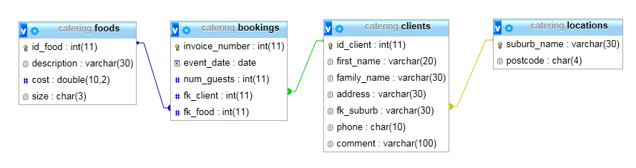

4. The locations table links the clients table on a one to many as each location may have many clients. The clients table links the bookings table and likewise the foods table, as clients may make more then one booking and certain foods may be ordered on many bookings.

5. Data Dictionary

|  |  |  |  |  |
| --- | --- | --- | --- | --- |
| Field name | Data type | Field Length | Constraint | Description |
| id_client | Int | 11 | Primary key | Client ID |
| first_name | Varchar | 20 | NOT NULL | First name |
| family_name | Varchar | 30 | NULL | Last name |
| address | Varchar | 30 | NULL | Client address |
| fk_suburb | Varchar | 30 | Foreign Key | Clients location |
| phone | Char | 10 | NULL | Phone number |
| comment | Varchar | 100 | NULL | Leaving comments |

Testing

6. Sql statement may be tested before implementation to the php files.

All commands should be tested and checked of by looking at the database to ensure the correct changes are being made.

7. Adding new client

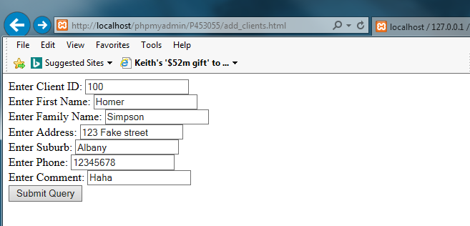



Editing a Booking

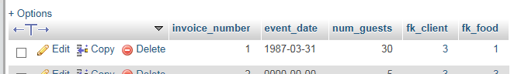

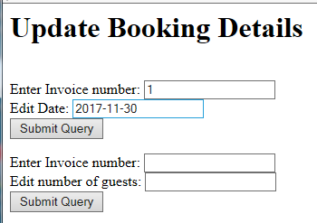

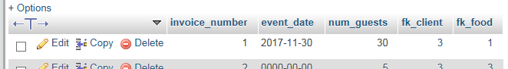

Calculate booking cost

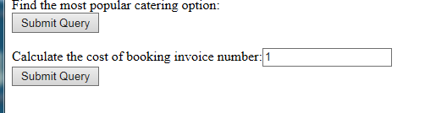

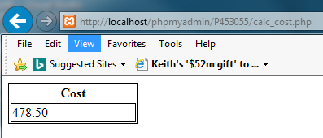

Security

8. To avoid displaying error messages to the public, alternative page links should be set in the catch part of a try method for site operations.

9. Secure login features with higher levels of access should be set to protect sensitive data from unauthorised access.

Recommendations

10. The integer data fields simply go blank if anything other than integers are enter, varchar fields will of course accept any character type.

If a new suburb if entered in the add clients fields an error will be thrown as suburb is a foreign key connecting to the locations table and so the constraint will fail.

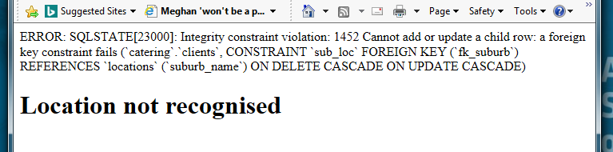

11. If there’s no connection to the database, the site fails to operate on commands.

12. This is an administration issue on the server side and an error report should be issued to deal with the connection.